Experiment No. 2

Title: Installation of Metasploitable

Roll No.: 16010420075 Experiments No.: 2

Aim: Installation of Metasploitable OS

\

Resources: virtual box, metasploitable, zip extractor (7zip)

Theory
The Metasploit Initiative is a computer security project that helps with penetration testing and IDS signature development by providing knowledge about security flaws. Rapid7, a security firm based in Boston, Massachusetts, owns it.
__________________________________________________________________________
IMPLEMENTATION AND RESULTS:
Steps to install Metasploitable on Virtual Box:
- Download from https://sourceforge.net/projects/metasploitable/ and extract the metasploitable file from zip extractor.
- Open the Virtual Box and click the new button on the top right side of your Virtual Box. On the first option, write Metasploitable and select Linux in the second option and Ubuntu in third option then click Next and go forward.
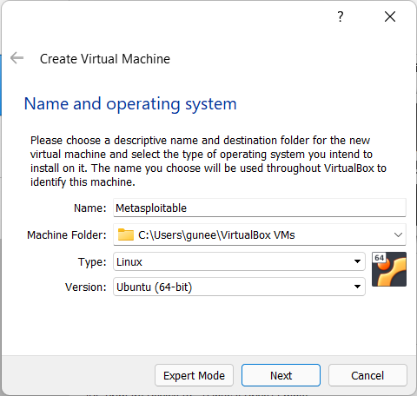
- Select the memory size (RAM). You can use it as a default or give some extra and click on next then next button.
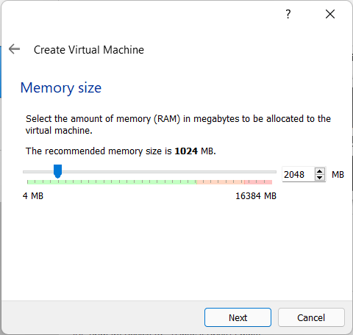
- Next, click on the second option to create the virtual hard disk for the OS, then click on Create to proceed.
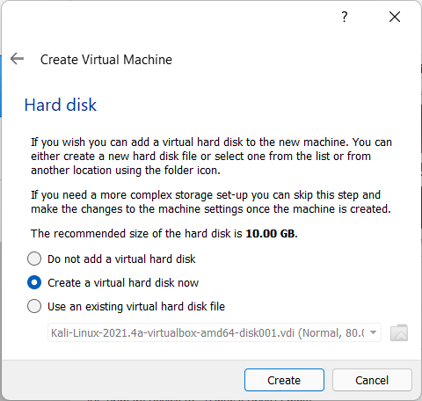
- This step, you will select the type of your Hard disk, and it is VHD (Virtualbox Hard Disk). After that, click on Next button and again click Next button.
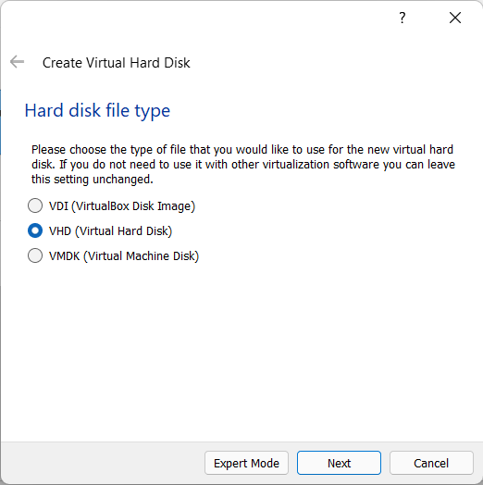
- Proceeding, we give the OS dynamic allocation of the storage. This will ensure that it does not take up all the space. Click next.
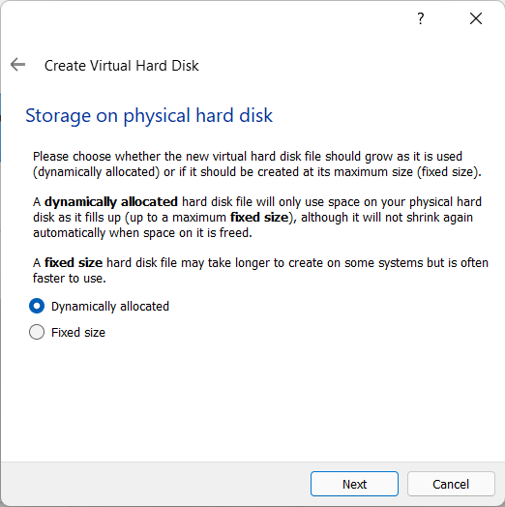
- Give it a default of 10 GB of space or set it according to your needs. The default location is in Users, set it accordingly or let it be the default. Then click Create.
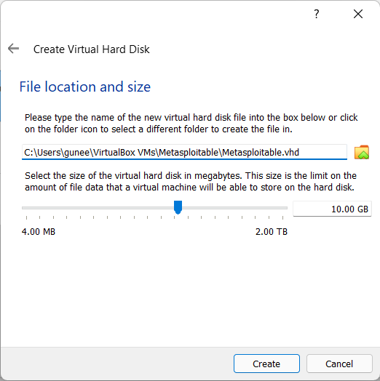
- Now the settings are fixed up, and we have to select our downloaded OS, and for that, we must click on the Storage button as the picture below.
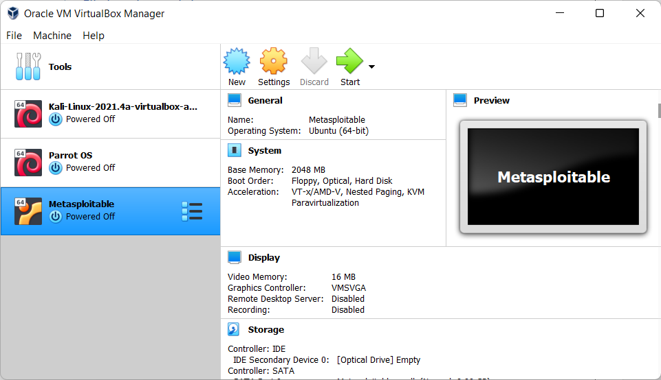
- Click on the small hard disk on the top right of the dialogue box as the picture. Then click “Choose/Create a Virtual Hard Disk”.
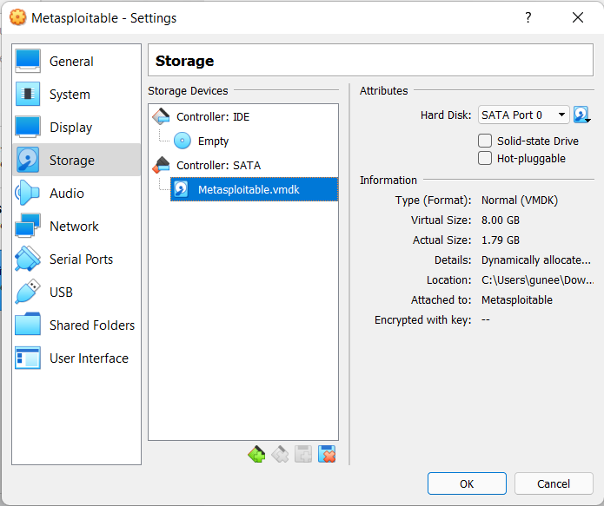

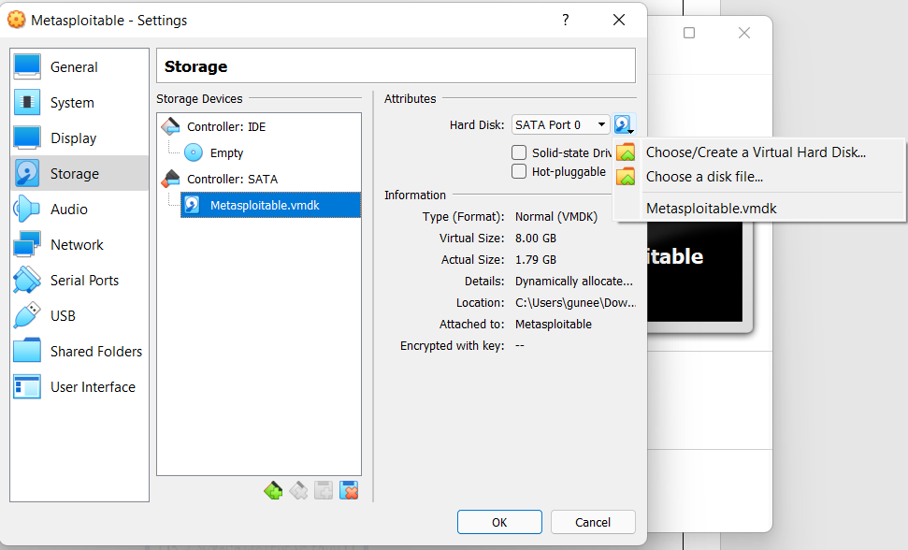

- Click Add
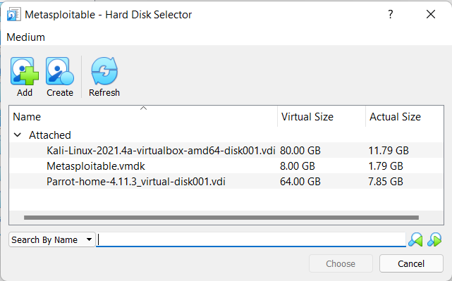
- Now go the directory that Metasploitable is downloaded and select Metasploitable.vdmk file and click open.
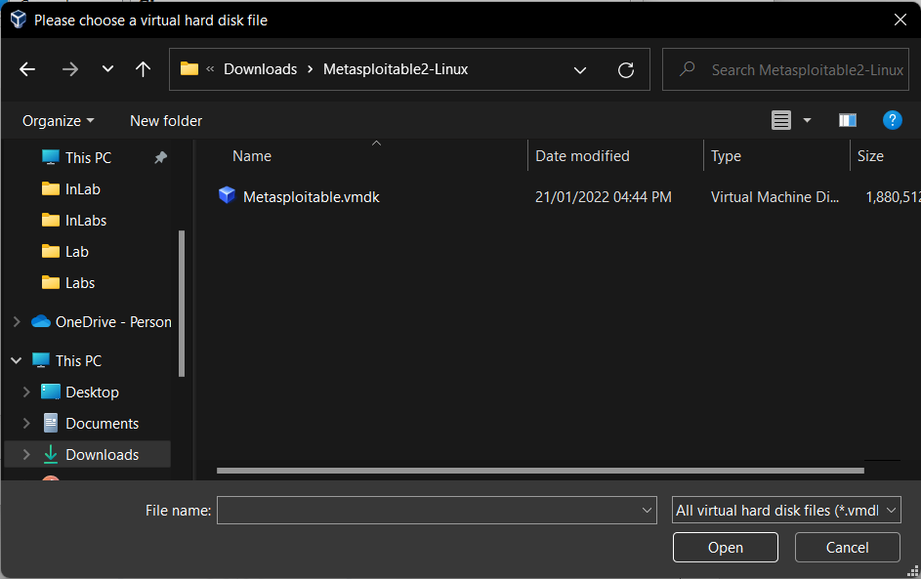
- Now that it’s done, go to the Metasploitable section and click “Start” to begin the software.
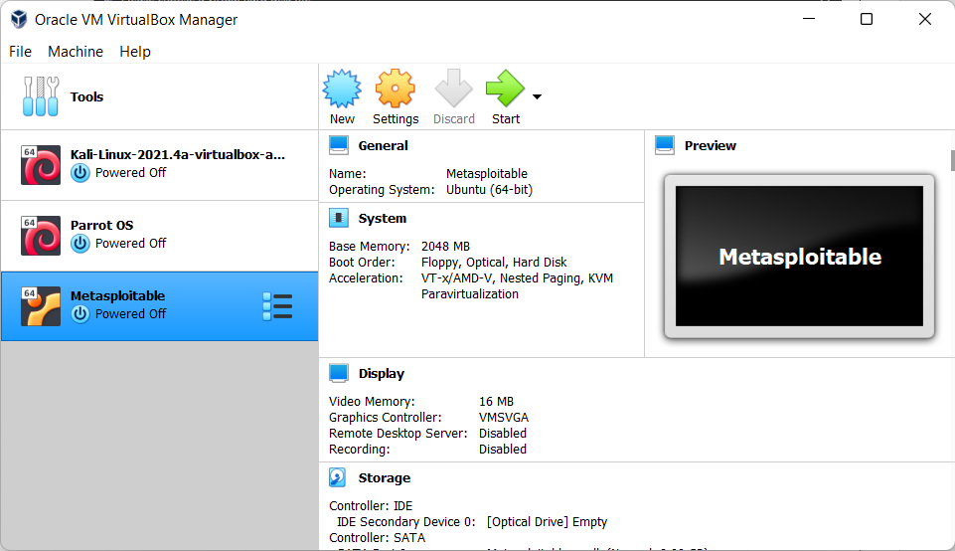
Outcomes:
_________________________________________________________________________
Conclusion: (Conclusion to be based on the objectives and outcomes achieved)
Metasploitable was successfully installed.
Grade: AA / AB / BB / BC / CC / CD /DD

Signature of faculty in-charge with date

__________________________________________________________________________

REFERENCES:
Install Metasploitable on Virtual Box | Ethical Hacking Tutorials, Tips and Tricks (hacking-tutorial.com)

